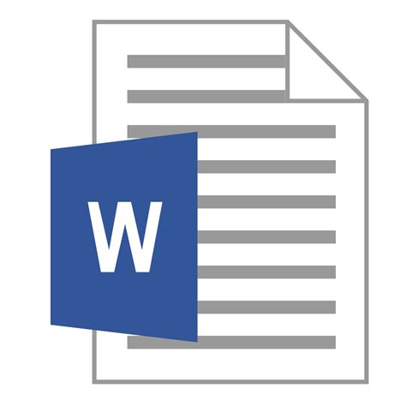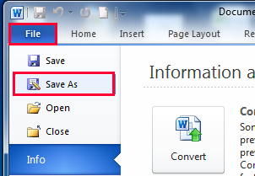**How to Save and Open a File**

Mr. Poliszuk

Technology 7

|  |
| --- |
| **Learning Target:** I can…  Explain and demonstrate how to Save and Open a file using my student H: drive. |
| Explain how to **Save** a File |
| Explain how to **Open** a file |
| When finished, quietly raise your hand to explain and demonstrate that you can successful save and open a file using your student H: drive. ☺ |

East Lower School – Rochester City School District